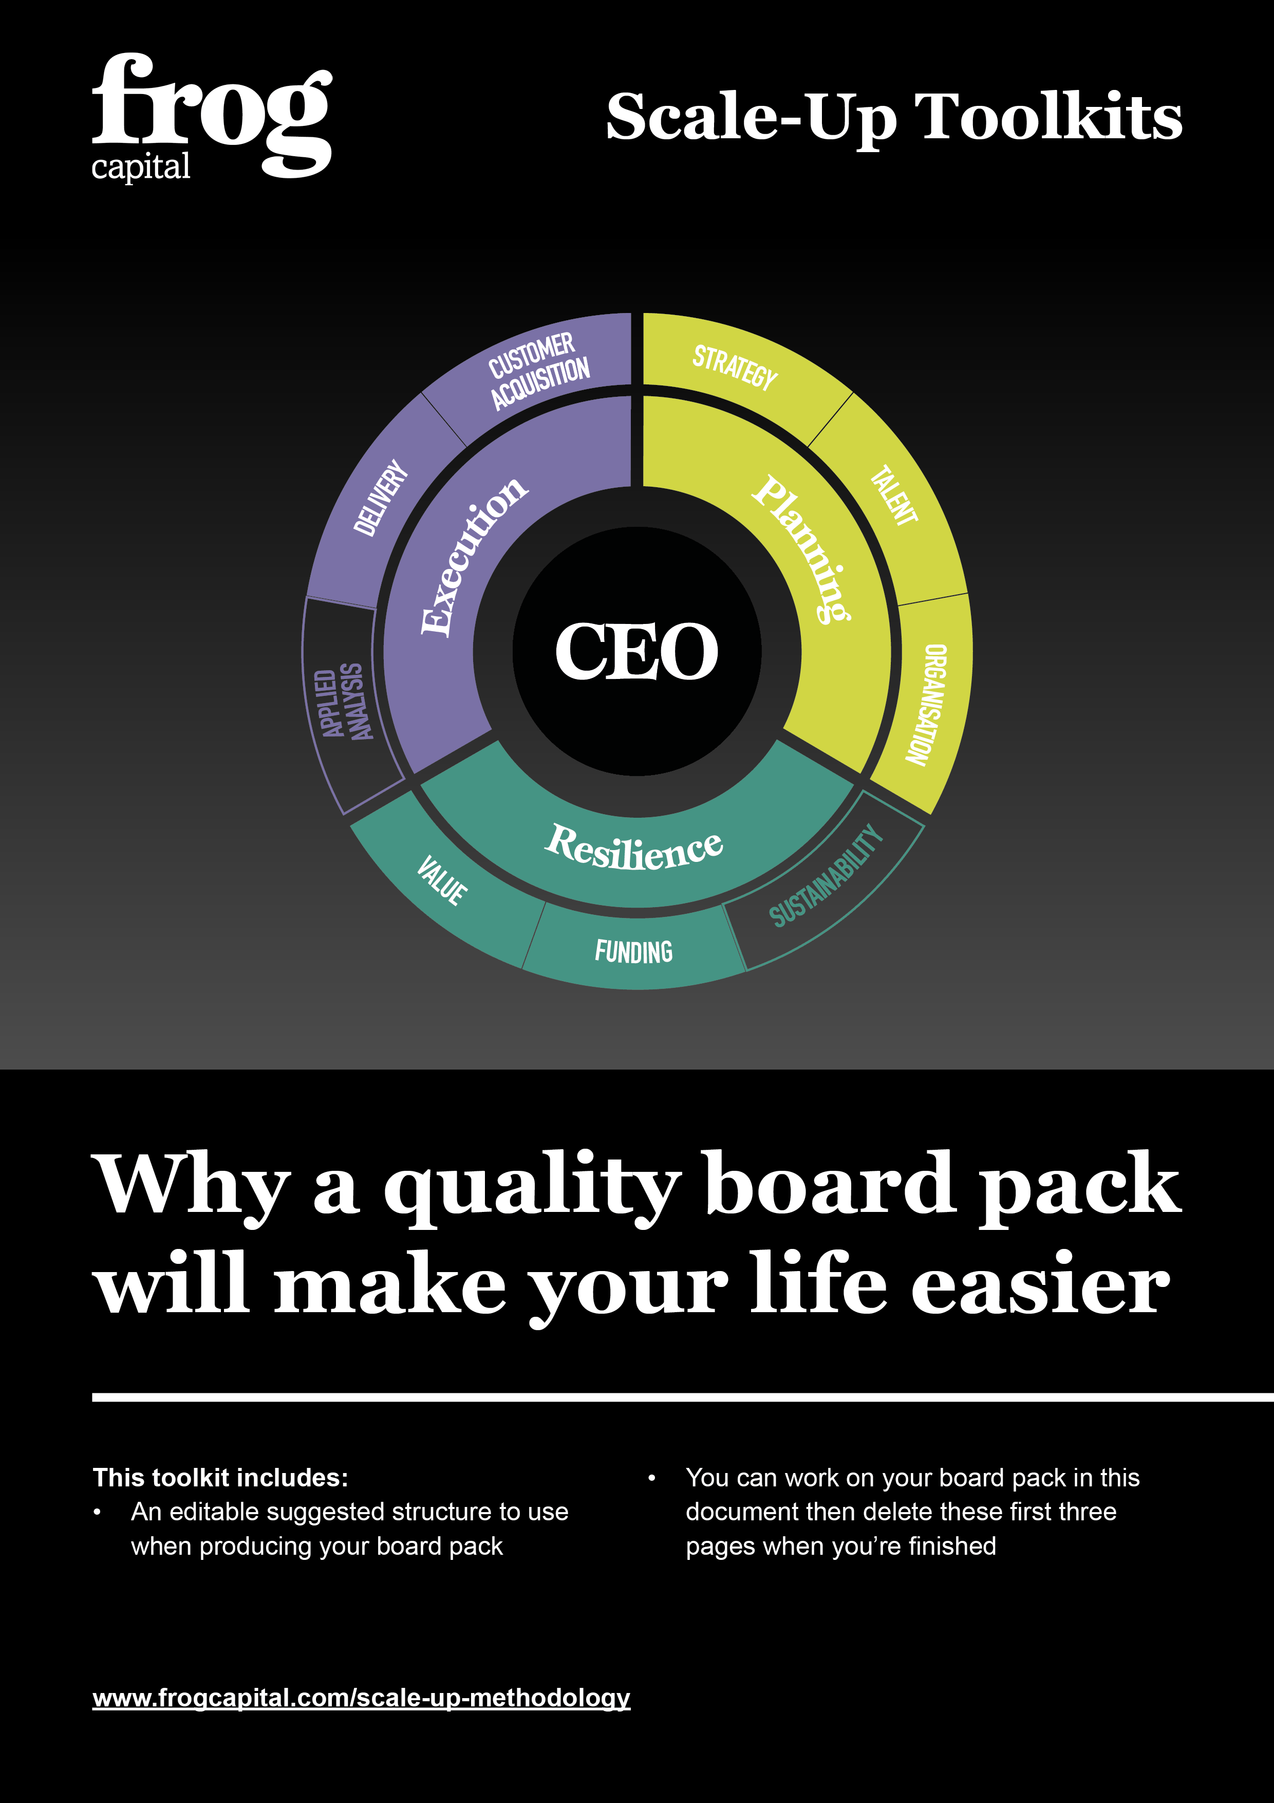
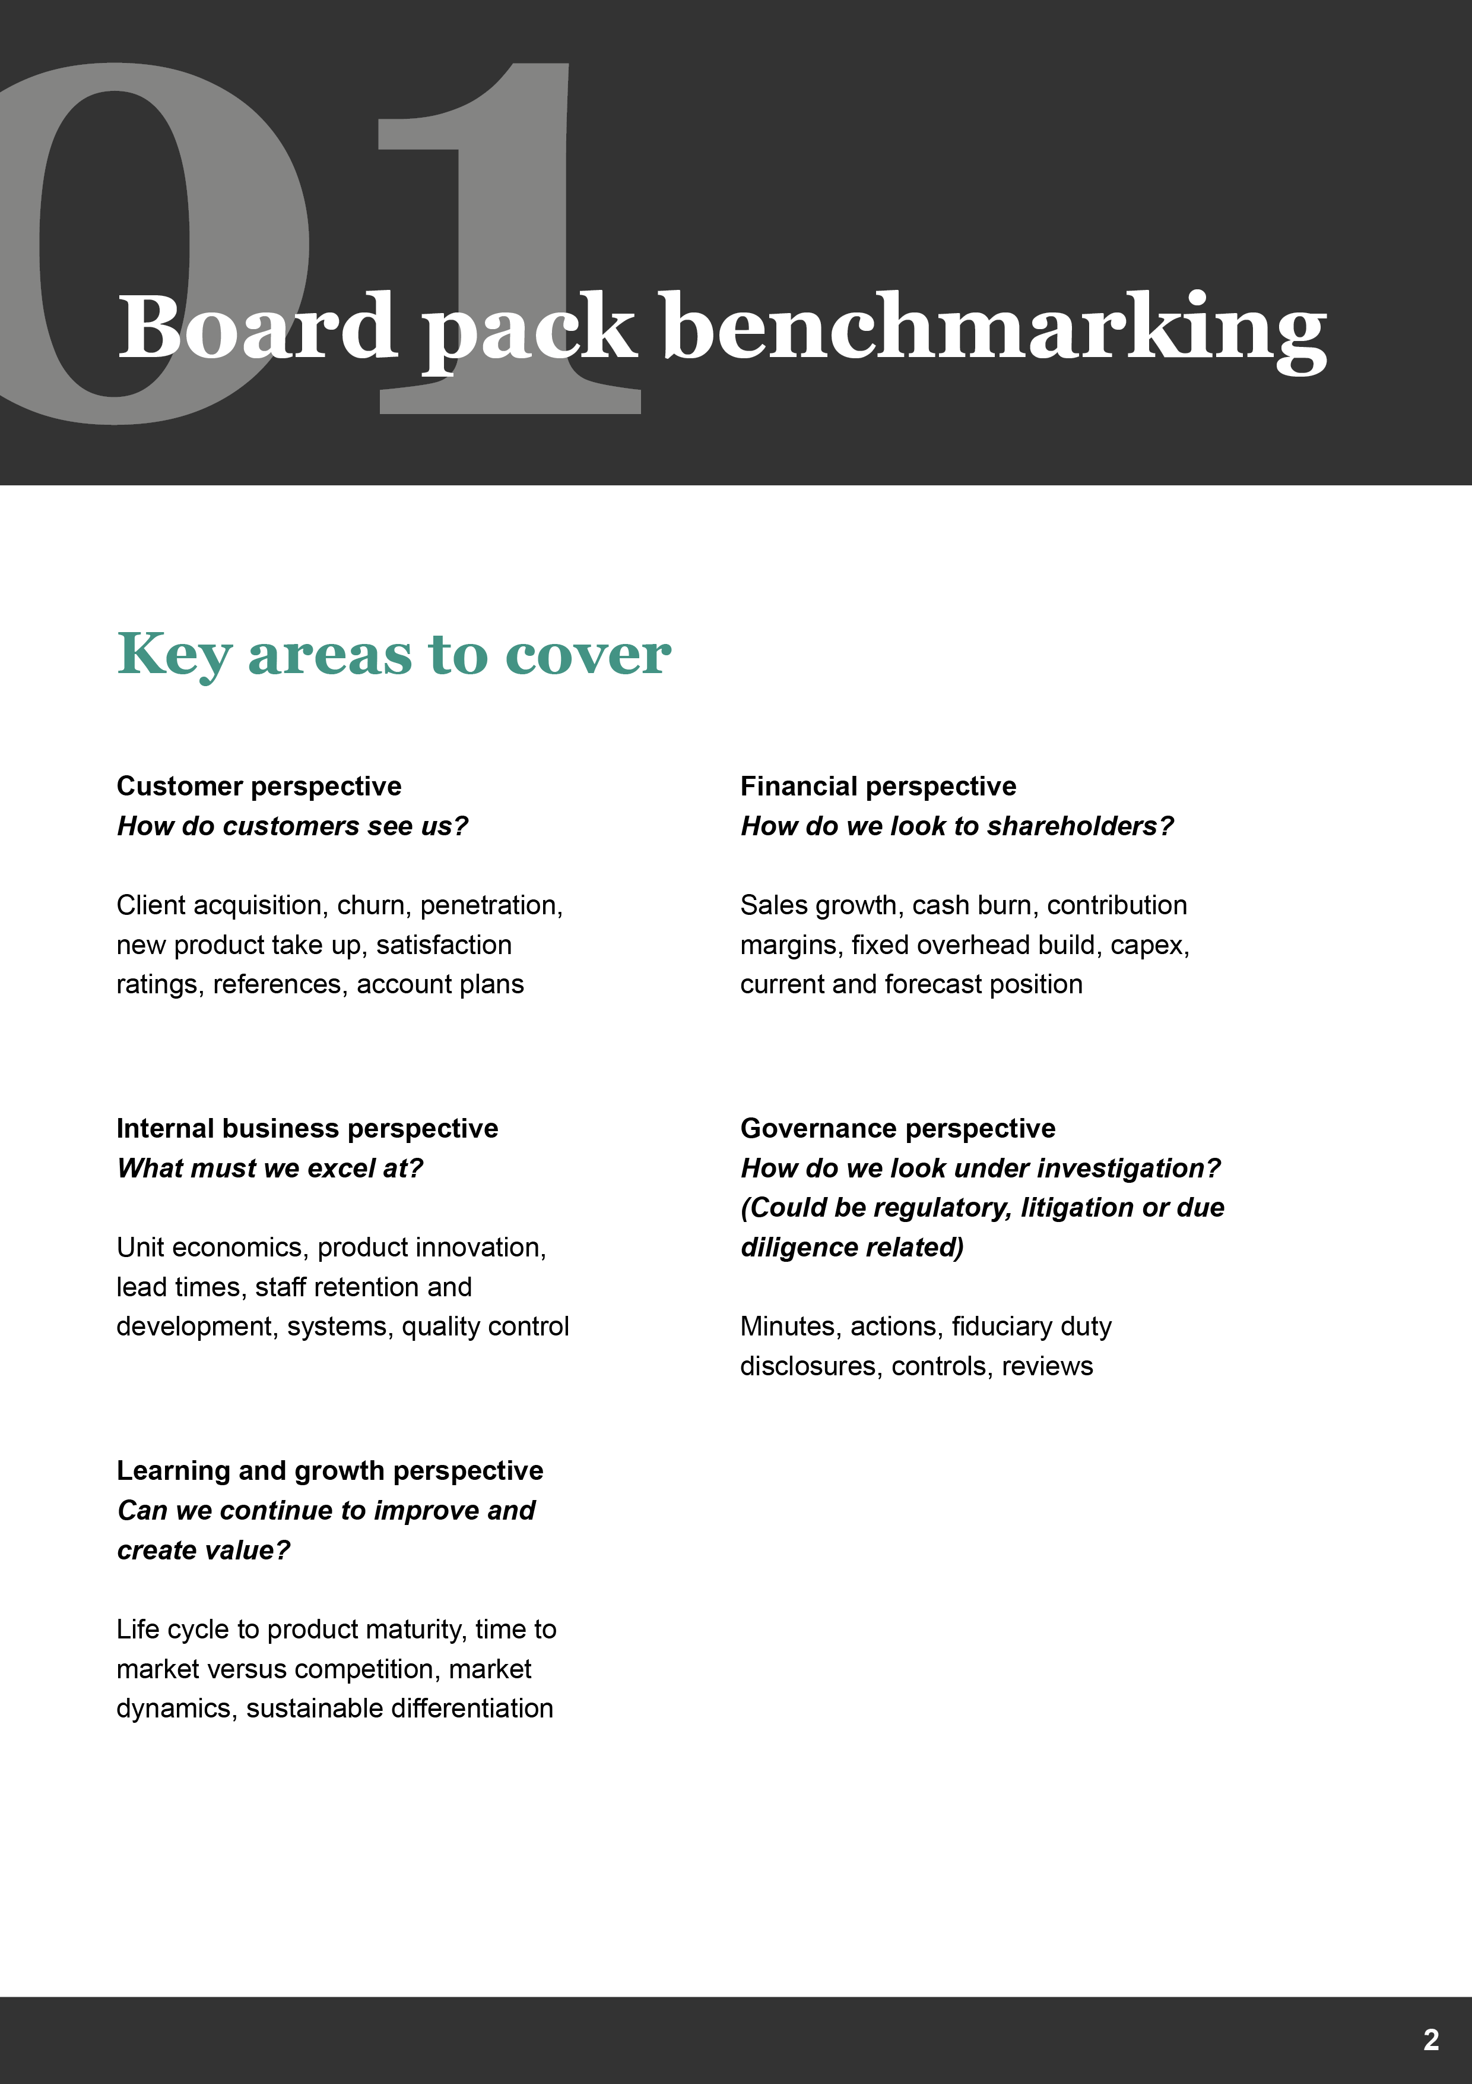
Board Pack

[Notes in square brackets and italicised are for reference and can be deleted once your board pack is completed.]

1. Agenda

2. Company secretarial [Governance perspective – usually run by CFO/Co Sec]
2.1 Prior minutes
[Conclusions and actions clearly recorded]

2.2 Open actions
[Responsibilities allocated, review each month until closed]

2.3 Other
[Share and option issues, changes of rights, director appointments etc]

3. CEO report [Learning and growth perspective]
3.1 High Level KPIs

3.2 Summary
[What’s going well, What’s not going so well, and Key Priorities for the Next Period]

3.3 Progress against longer term goals
[Green, Amber, Red]

3.4 Commentary on market developments and competition

4. Customers, Sales and Marketing
4.1 Existing Customers
[Customer satisfaction KPIs, Churn, Account growth]

4.2 Sales
[Pipeline KPIs, Progress to Quarter targets, Cost of Acquisition, Win/loss analysis, How good are you at forecasting]

4.3 Marketing
[KPI performance of marketing investment]

4.4 Team Performance

5. CFO report [Financial Perspective]
5.1 Commentary on Key Performance Indicators

5.2 Management accounts
[P&L, cash flow and balance sheet month and YTD v budget and prior year]

5.3 Revenue and Gross Margin analysis
[By client, product, geography as relevant]

5.4 Forecasts
[Cash flow and P&L full year outturn at least]

5.5 Funding update
[Current projects or timetable to meet future requirement]

5.6 Bank covenants
[If applicable]

6. COO/Operations report [Internal business perspective (includes CTO, CPO remit)]
6.1 Summary
[What’s going well, What’s not going so well, and Key Priorities for the Next Period]

6.2 Operational Delivery KPIs
[System downtime, Customer satisfaction issues, Key bottlenecks]

6.3 Product Roadmap
[Update with Roadmap milestones, progress against plan]

6.4 HR report
[(Often part of CFO report) – FTE by department v budget (list by name if < 50 FTE), departures and joiners with reasons, promotions, recruitment underway, 6 month recruitment plan (identifying what is in budget and not). Training and development summary.]

[If the business has a CTO or CPO they should produce their own report including predictive KPIs and linkage of their delivery schedules to the broader business performance.]

7. AOB: Special papers [e.g. planning cycle, reforecast, large capex, departmental reviews, new products etc]

8. Financial and Non-Financial Appendices
8.1 P&L actual to budget comparison

8.2 Cash-flow actual to budget comparison
[Include forecast]

8.3 Balance sheet actual to budget

