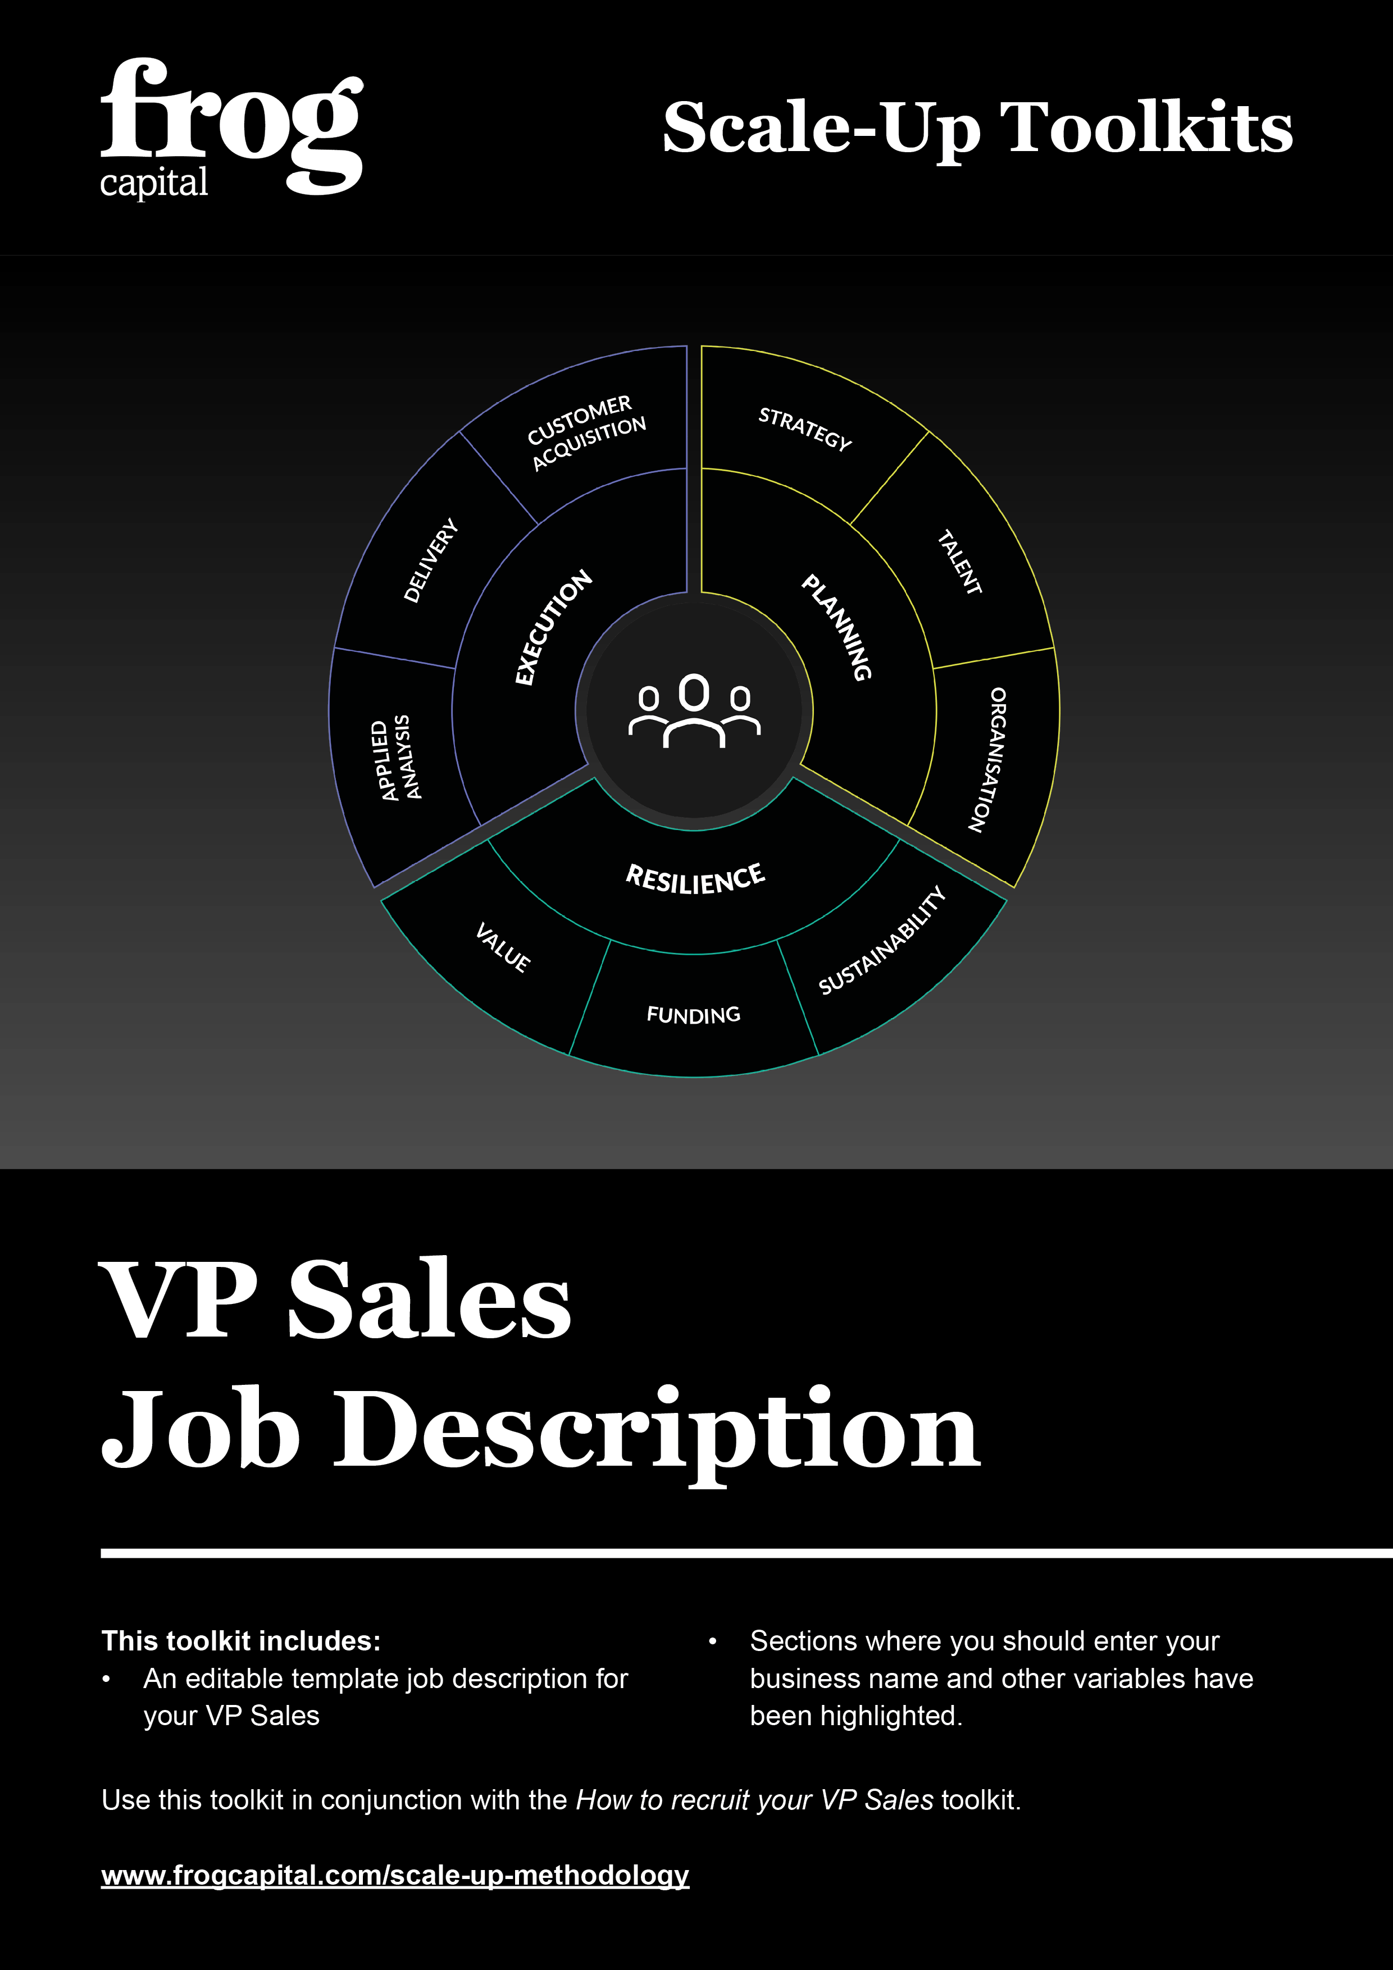
VP Sales Job Description

VP Sales – £/€[SALARY]

Contents
- About [YOUR BUSINESS NAME]
- Purpose of the Role
- Main Responsibilities
- Departmental Structure
- Skills and Experience
- Special Features of the Role
- Compensation

1. About [YOUR BUSINESS NAME]
[YOUR BUSINESS NAME] was formed as a partnership in [FOUNDING YEAR] providing products and services, which remains core to our main offering today. In [FOUNDING YEAR], [YOUR BUSINESS NAME] repositioned itself as the specialist provider of choice for clients within the Europe, providing outsourced processing and fulfilment services.
[YOUR BUSINESS NAME] has grown significantly since [FOUNDING YEAR]. With an acquisitive focus and the continued launch of new products and services that meet market requirements, it is now established as the leading management company for Europe.
Our continued success, culminated in a management buy-out in [YEAR], enabling [YOUR BUSINESS NAME] to continue investing in technology and expertise that create innovative solutions. With our expanding teams, dedicated to delivering excellence in everything we do, we aim to achieve even greater results for our clients through this added power behind the business.
Our knowledge of the European sector is renowned. Through knowledge comes experience and through experience comes expertise. This expertise has earned us a valued and respected reputation with long- term clients. It is our stated aim to make [YOUR BUSINESS NAME] the undisputed market leader by [YEAR]. We will achieve this through a mixture of organic growth and acquisition; however, we need exceptional people demonstrating the right behaviours on a daily basis. This job description sets out how you can make your own contribution to the next stage in our company’s growth.

2. Purpose of the Role
- To develop and direct the implementation of commercial plans to improve current levels of business and identify new market opportunities.
- To ensure the effective promotion of [YOUR BUSINESS NAME]’s services and achievement of its overall targets.
- To control the Sales and Marketing functions for the company to achieve agreed sales volumes.
- To create and deliver a plan that will meet the objectives of [YOUR BUSINESS NAME]’s sales strategy.
Given the high-growth nature of the business, you will be required to work late nights or on occasions, weekends.

3. Main Responsibilities
Targets
- To take full responsibility for the delivery of the set quarterly and annual revenue target. This is the minimum expectation.
- To build a pipeline of sufficient quality to deliver the subsequent year’s target.
- To deliver clean, quality business, such that the company’s overall EBITDA (profit) number is successfully achieved.

Management
This means taking management responsibility for all quota-carrying staff. You will be required to recruit, coach and performance-manage all individuals in your team and any more that we would wish to add in the future. They must be appropriately motivated and trained to meet all their targets and you must ensure that they carry out their responsibilities to the required standard.
- Lead, manage and develop the team. This includes:
  - Setting objectives and expectations
  - Conducting one-to-one meetings
  - Reviewing performance
  - Giving feedback
  - Identifying training and development needs
  - Coaching and mentoring
  - Conducting annual appraisals
  - Addressing shortfalls in performance or acceptable behaviour
  - Recruitment
  - Succession planning
  - Talent identification
- Review their activities on a weekly basis at a minimum.
- Fulfil the standard managerial administration tasks, e.g. holidays, sickness, company equipment, discipline, recruitment etc.
- Take responsibility for identifying training requirements and liaising with HR to meet these.
- Ensure your team meet every quarter to review performance, share best practice and communicate with other teams in the business.
- Control the budget for the Sales function to ensure that all financial objectives are achieved without undue risk. Also, to ensure that the department complies with all company and regulatory requirements.
- Develop effective communications with internal managers and colleagues to keep up-to-date with [YOUR BUSINESS NAME]’s delivery capabilities and to inform them of any new sales development.
- Promote and represent the interests of the company at senior levels, including to government, key clients, partners and relevant trade organisation

Strategy
- Create and implement sales strategies that enable [YOUR BUSINESS NAME] to achieve its corporate objectives.
- Identify and develop new initiatives to improve the range and quality of the services provided by the company and to ensure responsiveness to changes in the external environment.
- Contribute to research into new and established markets to ensure that [YOUR BUSINESS NAME] develops products and services that meet market demand, and which are consistent with the company’s corporate strategy.
- Develop and maintain relationships with key clients and other relevant bodies to ensure that [YOUR BUSINESS NAME]’s maximum sales potential is realised.
- Maintain an awareness of developments in sales techniques and technologies, to ensure that [YOUR BUSINESS NAME] reinforces its competitive positioning.
- Monitor the sales performance and propositions of the competitors to ensure that [YOUR BUSINESS NAME] can react promptly and effectively to threats.

Process
- Develop all necessary procedures and processes to ensure that the sales team operates efficiently and effectively and achieves all its objectives.
- Monitor the performance of the Sales function through effective sales controls and take remedial action where necessary to ensure sales targets are met.
- Take ownership of [YOUR BUSINESS NAME]’s Bid Review Process, thereby ensuring all sales opportunities are properly qualified and a winning plan for each is put in place.
- Create, develop and refine sales plans for all accounts, markets or territories, working in conjunction with the relevant individuals in your team.
- Work in an integrated and collaborative way with other teams in [YOUR BUSINESS NAME], particularly Marketing, Client Services, IT and Operations.

Reporting
- Initially, meet with the CEO every week to review your team’s and your own activities.
- Attend any management meetings held in head office with the rest of the Senior Management Team.
- Complete a written monthly report for the CEO to incorporate into the Board Pack. The report must contain, as a minimum:
  - An overview of the previous month’s activities
  - The current status of agreed KPIs
  - An updated forecast
  - Any personnel issues
- This must be presented in draft form at the same time every month for approval.

4. Organisational Structure

5. Skills and Experience
- Qualification to degree level.
- At least 10 years’ sales management experience.
- At least 5 years’ sales or marketing experience in the relevant sector.
- An ability to sell products, services and solutions both directly and through partners or a channel.
- Thorough knowledge of effective marketing techniques.
- Excellent interpersonal and communication skills.
- First-class planning and organisational skills. This must include a clear understanding of the sales process which should include the following disciplines: qualification, forecasting, account planning and board reporting.
- Solid grasp of financial concepts/tools such as budgeting, cash flow and the balance sheet. Ideally some P&L ownership is desirable.
- Impressive, demonstrable record of over-achievement on targets.

6. Special Features of the Role
- You will be required to travel all over the Europe to meet clients, prospects and partners.
- This travelling may require some overnight stays.
- You may be asked to attend board meetings with the Executive team, our Chairman and investors, either in the head office or elsewhere.

7. Compensation
[To be determined by the CEO]

