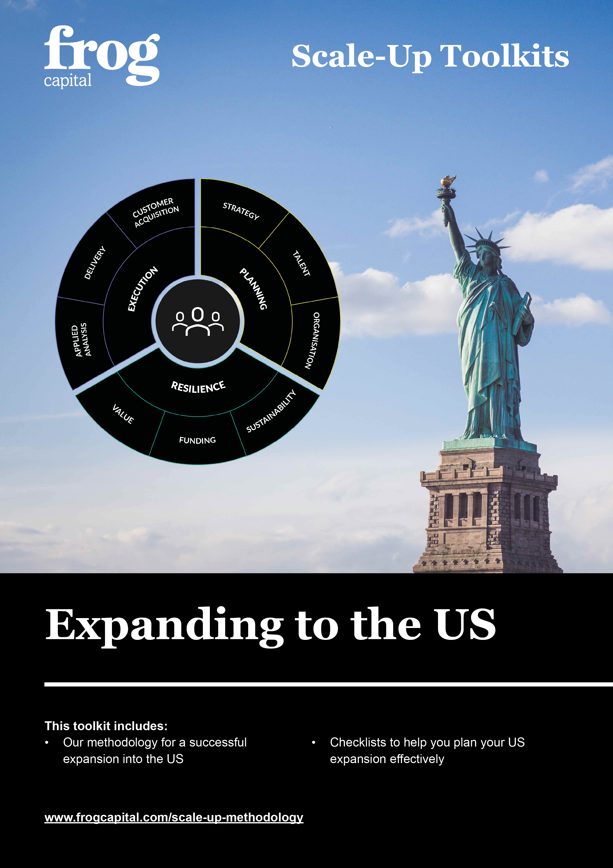

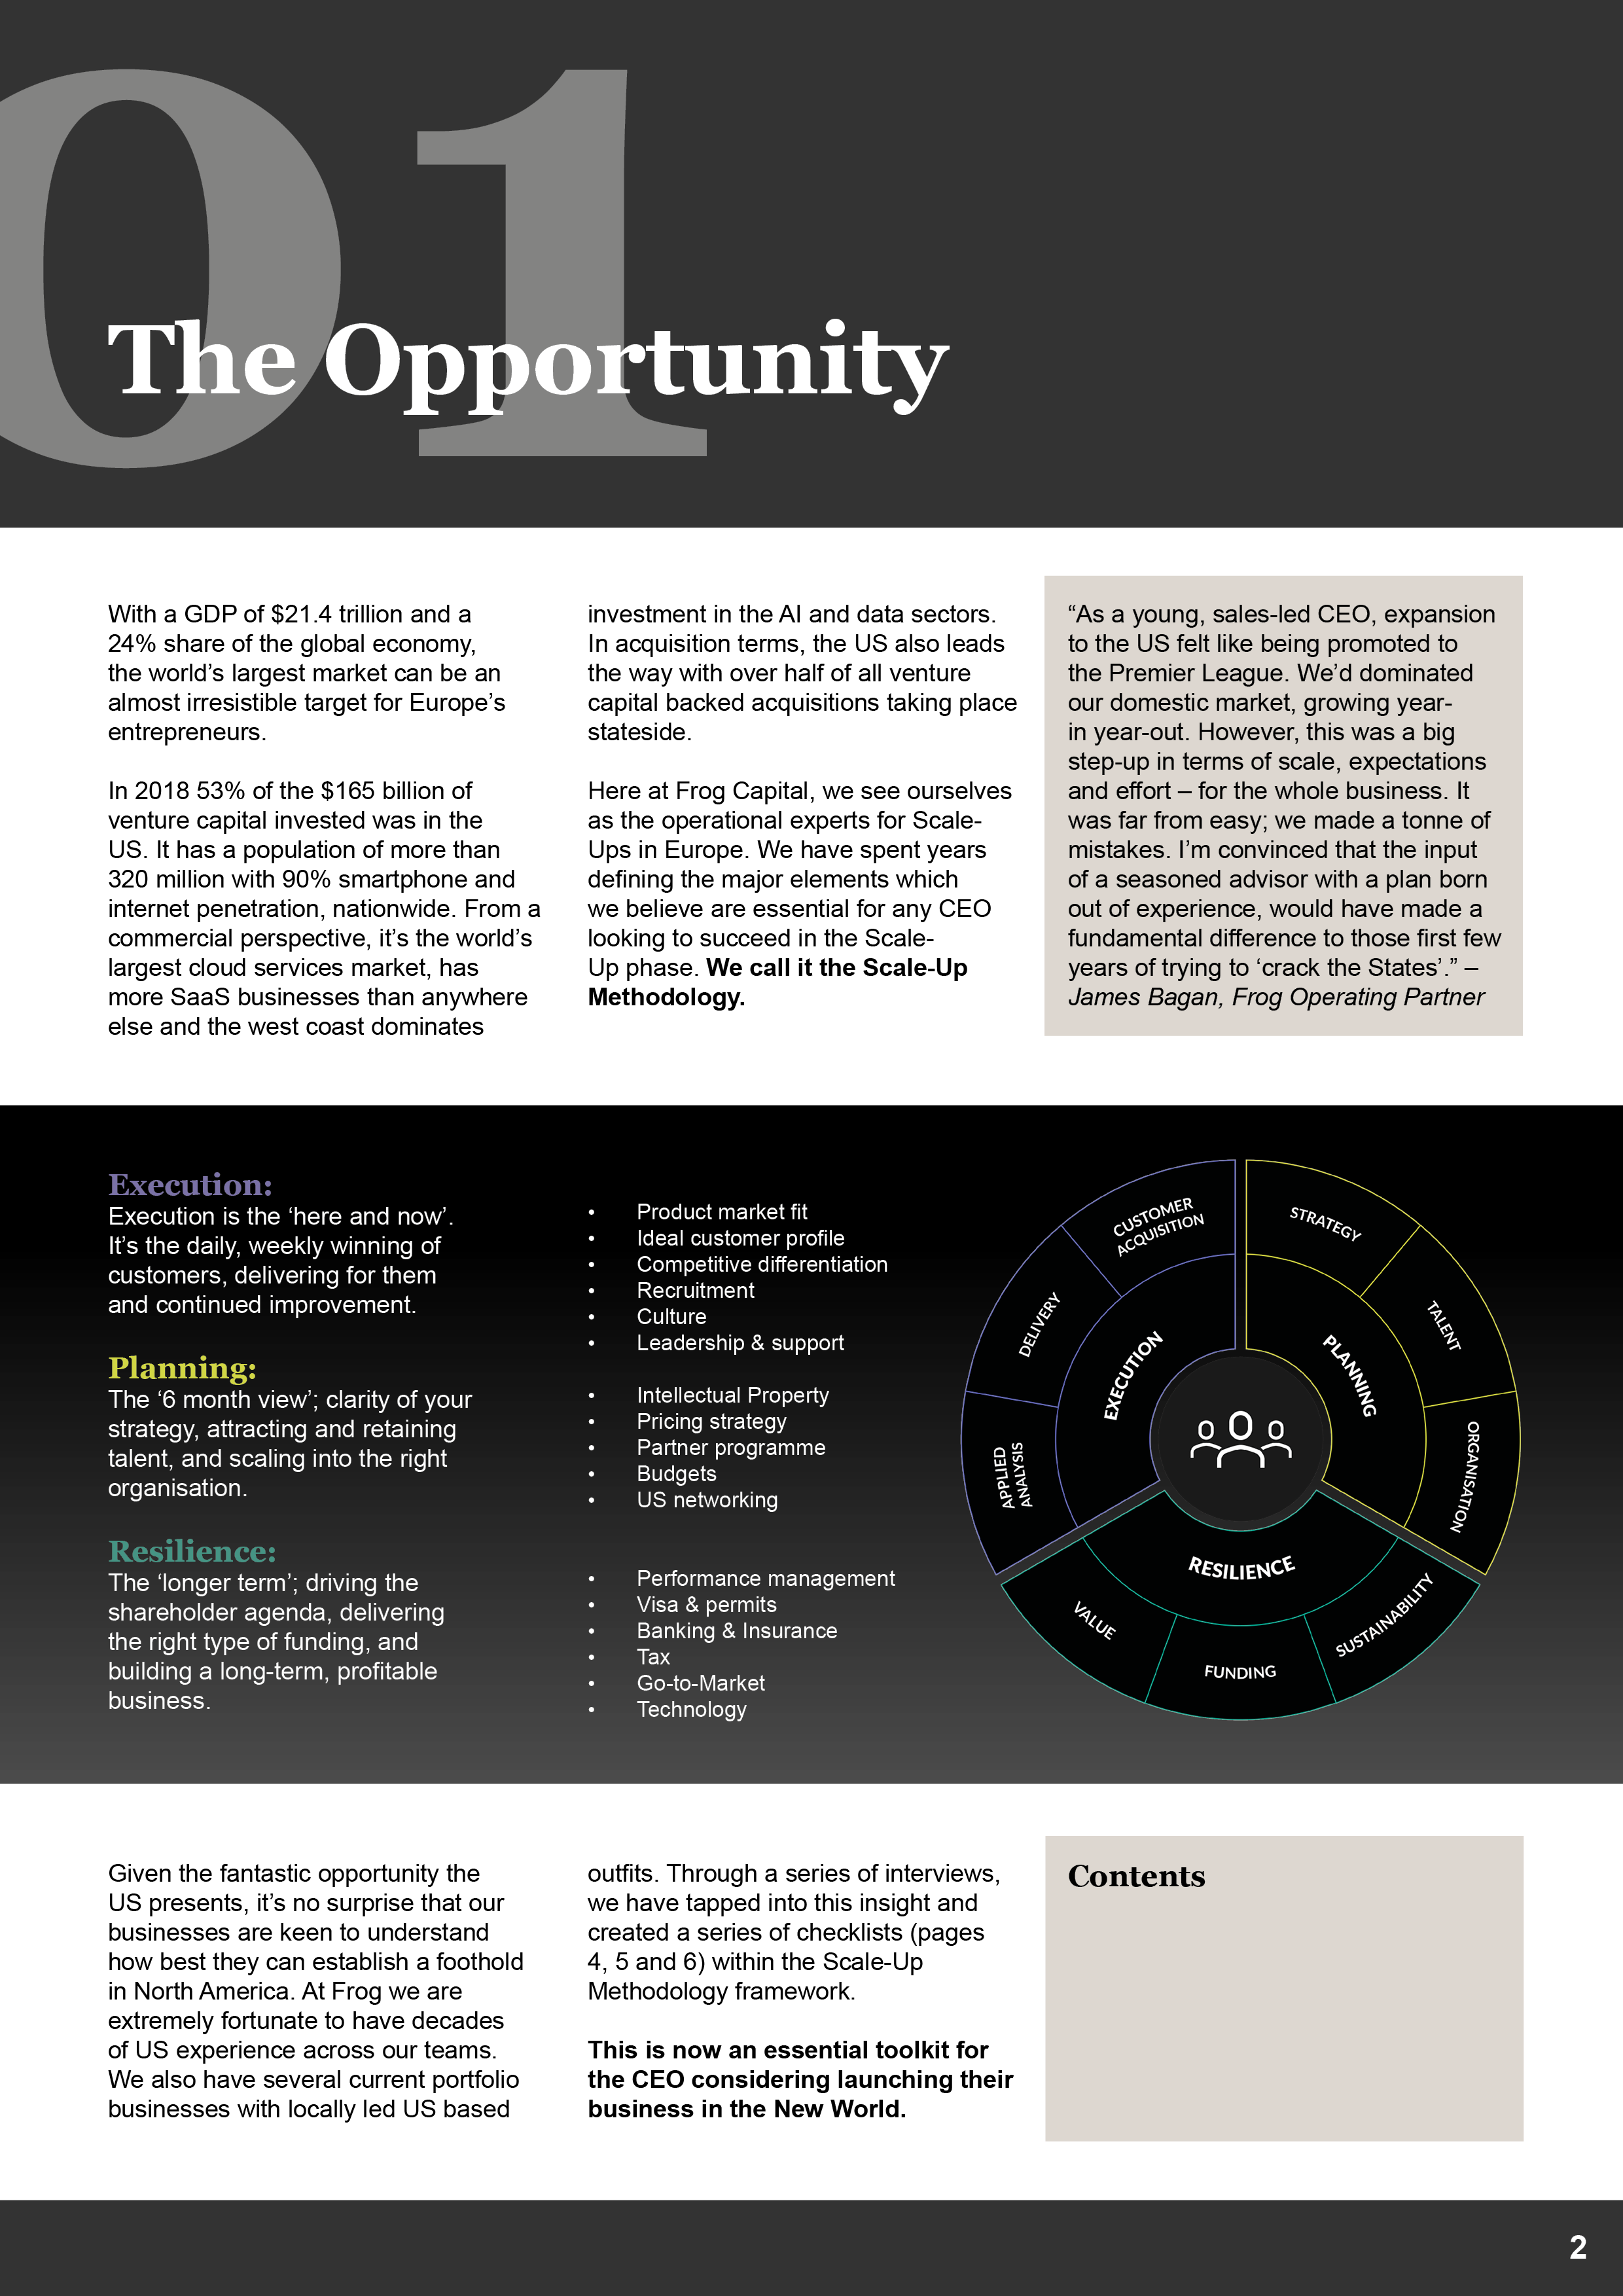
Click to navigate

The Decision
Scale-Up

Planning
Resilience
Execution

Summary
Case Study
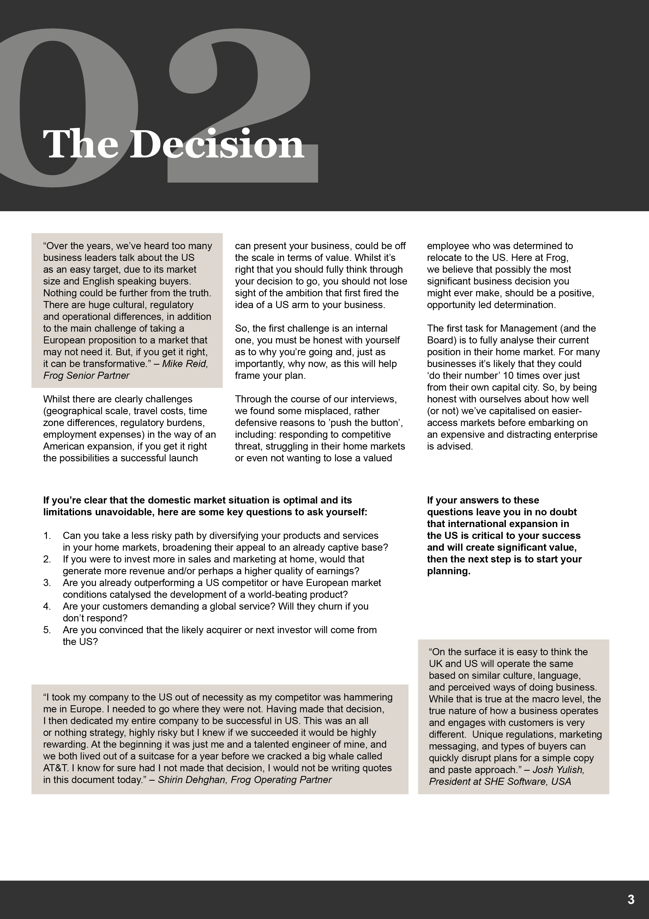

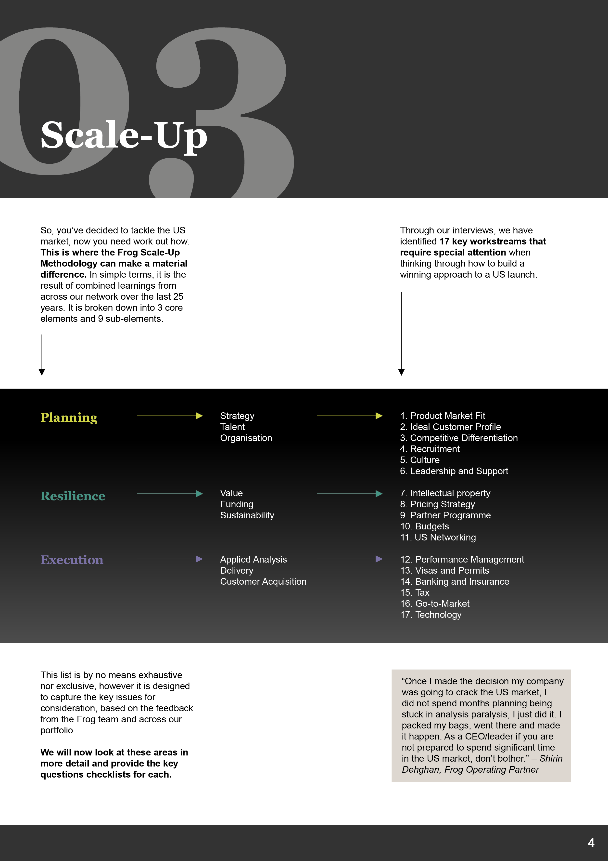

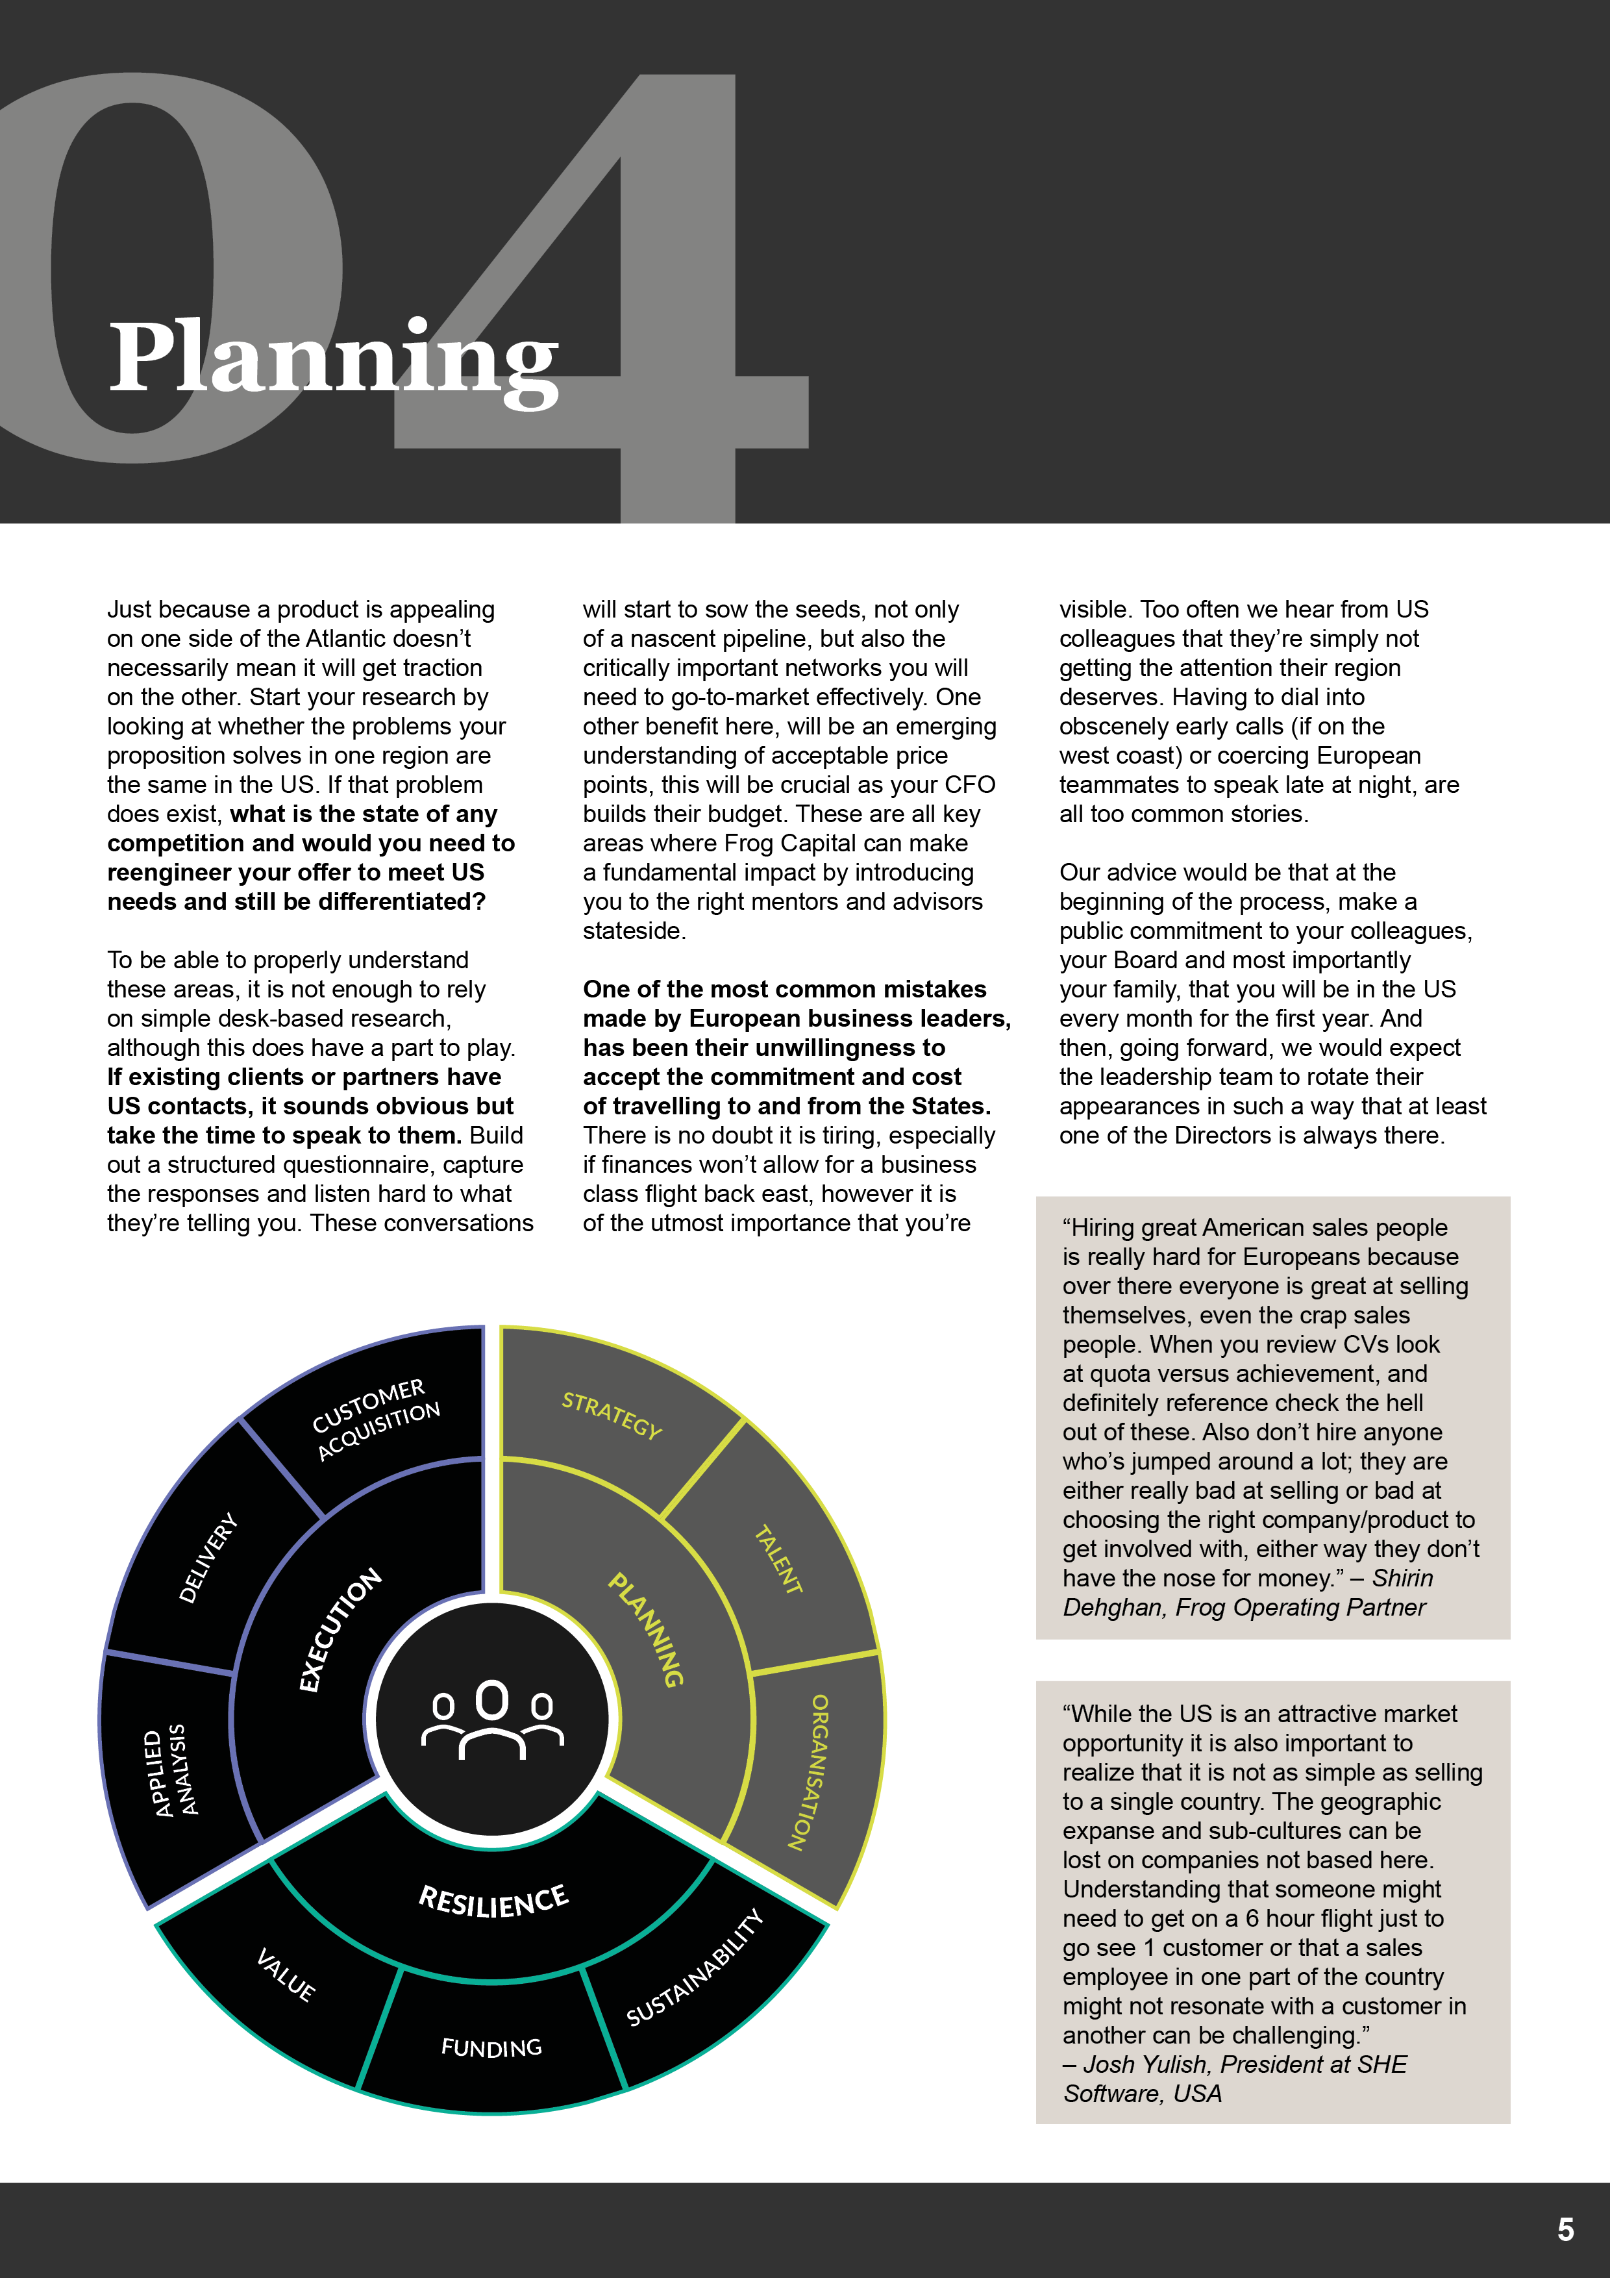

Planning Checklist
Fill in your answers below each question
# | Question | Follow-Up
1 | Is there a market opportunity for your proposition in the US? | Can this need be quantified?
2 | Are there any existing solutions or competitors in play right now? | Is your current proposition ready to deploy and is it better than any existing provisions?
3 | From your analysis, are you able to segment the US market by sector and/or region? | Are you able to describe your Ideal Customer Profile?
4 | Who is going to lead the operation and what does that mean for their incumbent responsibilities? | How will you support this individual remotely, so they have access to decision-making capability in their own time zone?
5 | Has the senior team bought into the obligations and expense of frequent transatlantic travel? | Going forward, are all functions: finance, sales, marketing, IT, HR, product all taking their turn to visit prospects, partners and new colleagues?
6 | Are you planning to replicate the current ‘European’ culture in the US? If you are, think again. | Is it possible to set standards and expectations of behaviour that cross countries, whilst allowing, even encouraging, different styles to develop?
7 | Are you going to recruit local people from the start? If you are you will need a fantastic recruiter and a big budget. Talent costs more in the US. | With salespeople it can often make sense to recruit ‘black-book’ sellers who have direct access to decision-makers. These guys may not last for ever but will get you moving quickly in early days.

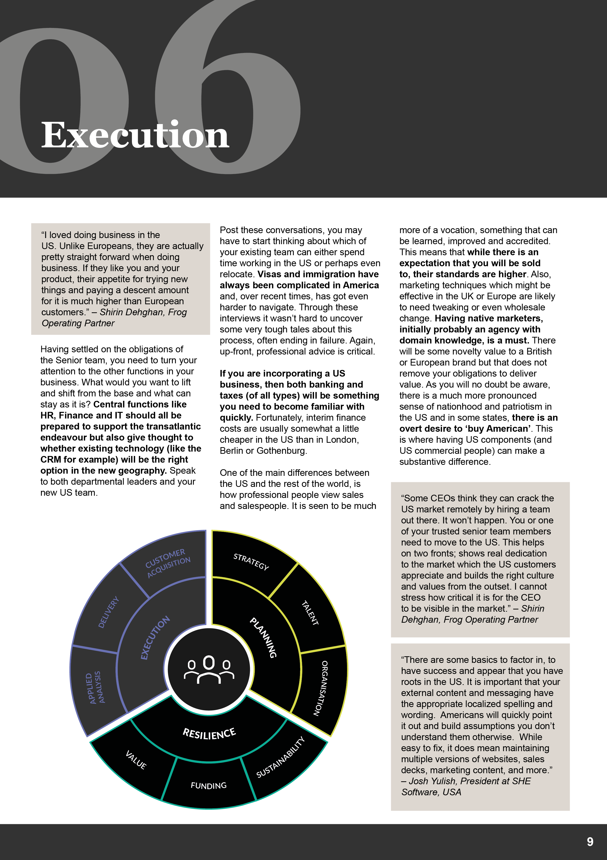

Resilience Checklist
Fill in your answers below each question
# | Question | Follow-Up
1 | Have you built a realistic financial model which has been rigorously scrutinised? Can the Frog team help here by reviewing it too? | Is there a proper set of controls and proof points in place at all levels? Does the US leader know what their authority level is? How are Board expectations set and managed?
2 | Have you qualified the level of risk around your Intellectual Property in the US? | Will you need to invest in proper protection through the USPTO?
3 | If you have limited or no US client exposure, you have no brand. Have you fully considered both the time and cost of doing this properly? | Marketing is very different in the US, look to hire someone with experience of working in your primary sector.
4 | Is your customer research detailed enough to inform an emerging pricing strategy? | Will you ‘price-to-win’ early on or is there sufficient margin for value-based pricing?
5 | Are you able to identify a cohort of partners who can help deliver long-term revenue streams? | Can these partners be organised into a professional programme? Is there a potential acquirer in here?
6 | Is there a native, well connected industry heavyweight who can facilitate introductions? | Could this person also act as a Board Advisor or NXD, supporting the US leader?

Execution Checklist
Fill in your answers below each question
# | Question | Follow-Up
1 | Which centralised functions can provide support to the new US satellite? Is this services and/or technology based? | Remember to factor in time zones (9 in the US!) when organising support services. And ensure, that any tech you redeploy is properly licensed and serviced (e.g. training or bespoke reports).
2 | Are you clear on both your federal and state tax obligations? | Will you be in a regulated sector, e.g. financial services?
3 | Do you fully understand your position on visas, office permits (if taking premises) and other regulations? | Have you found experienced, referenceable US legal counsel?
4 | If incorporating in the US, do you have the right banking and insurance options? | Do you understand your obligations as an employer, e.g. social security, Medicare etc?
5 | Is there a specialist agency, who can begin raising awareness and creating interest? | Working with them, are you able to start building a realistic marketing budget for year 1 at least?
6 | If you have limited or no US client exposure, you have no brand. Have you fully considered both the time and cost of doing this properly? | Marketing is very different in the US, look to hire someone with experience of working in your primary sector.

Here are the top ten takeaways from this paper:

Summary Checklist
Fill in your answers below each question
# | Question
1 | Have you fully exploited the potential in your current markets?
2 | Can you clearly identify US opportunities now, from existing clients and partners?
3 | Will your proposition be compelling for US customers, or does it need radical development?
4 | Can you sell it at a price they will buy without seeing your margins compromised?
5 | Do you fully understand your US competitive positioning?
6 | Do you have the cash and a realistic budget to give your expansion the time to succeed?
7 | Have you identified the right operational leader and protected their existing responsibilities?
8 | Is your go-to-market plan fully funded with US sales and marketing expertise baked in?
9 | Have you thought through US issues such as taxes, IP, employment, office locations and legals?
10 | Can your investor actively support you throughout all the stages of a US expansion?

