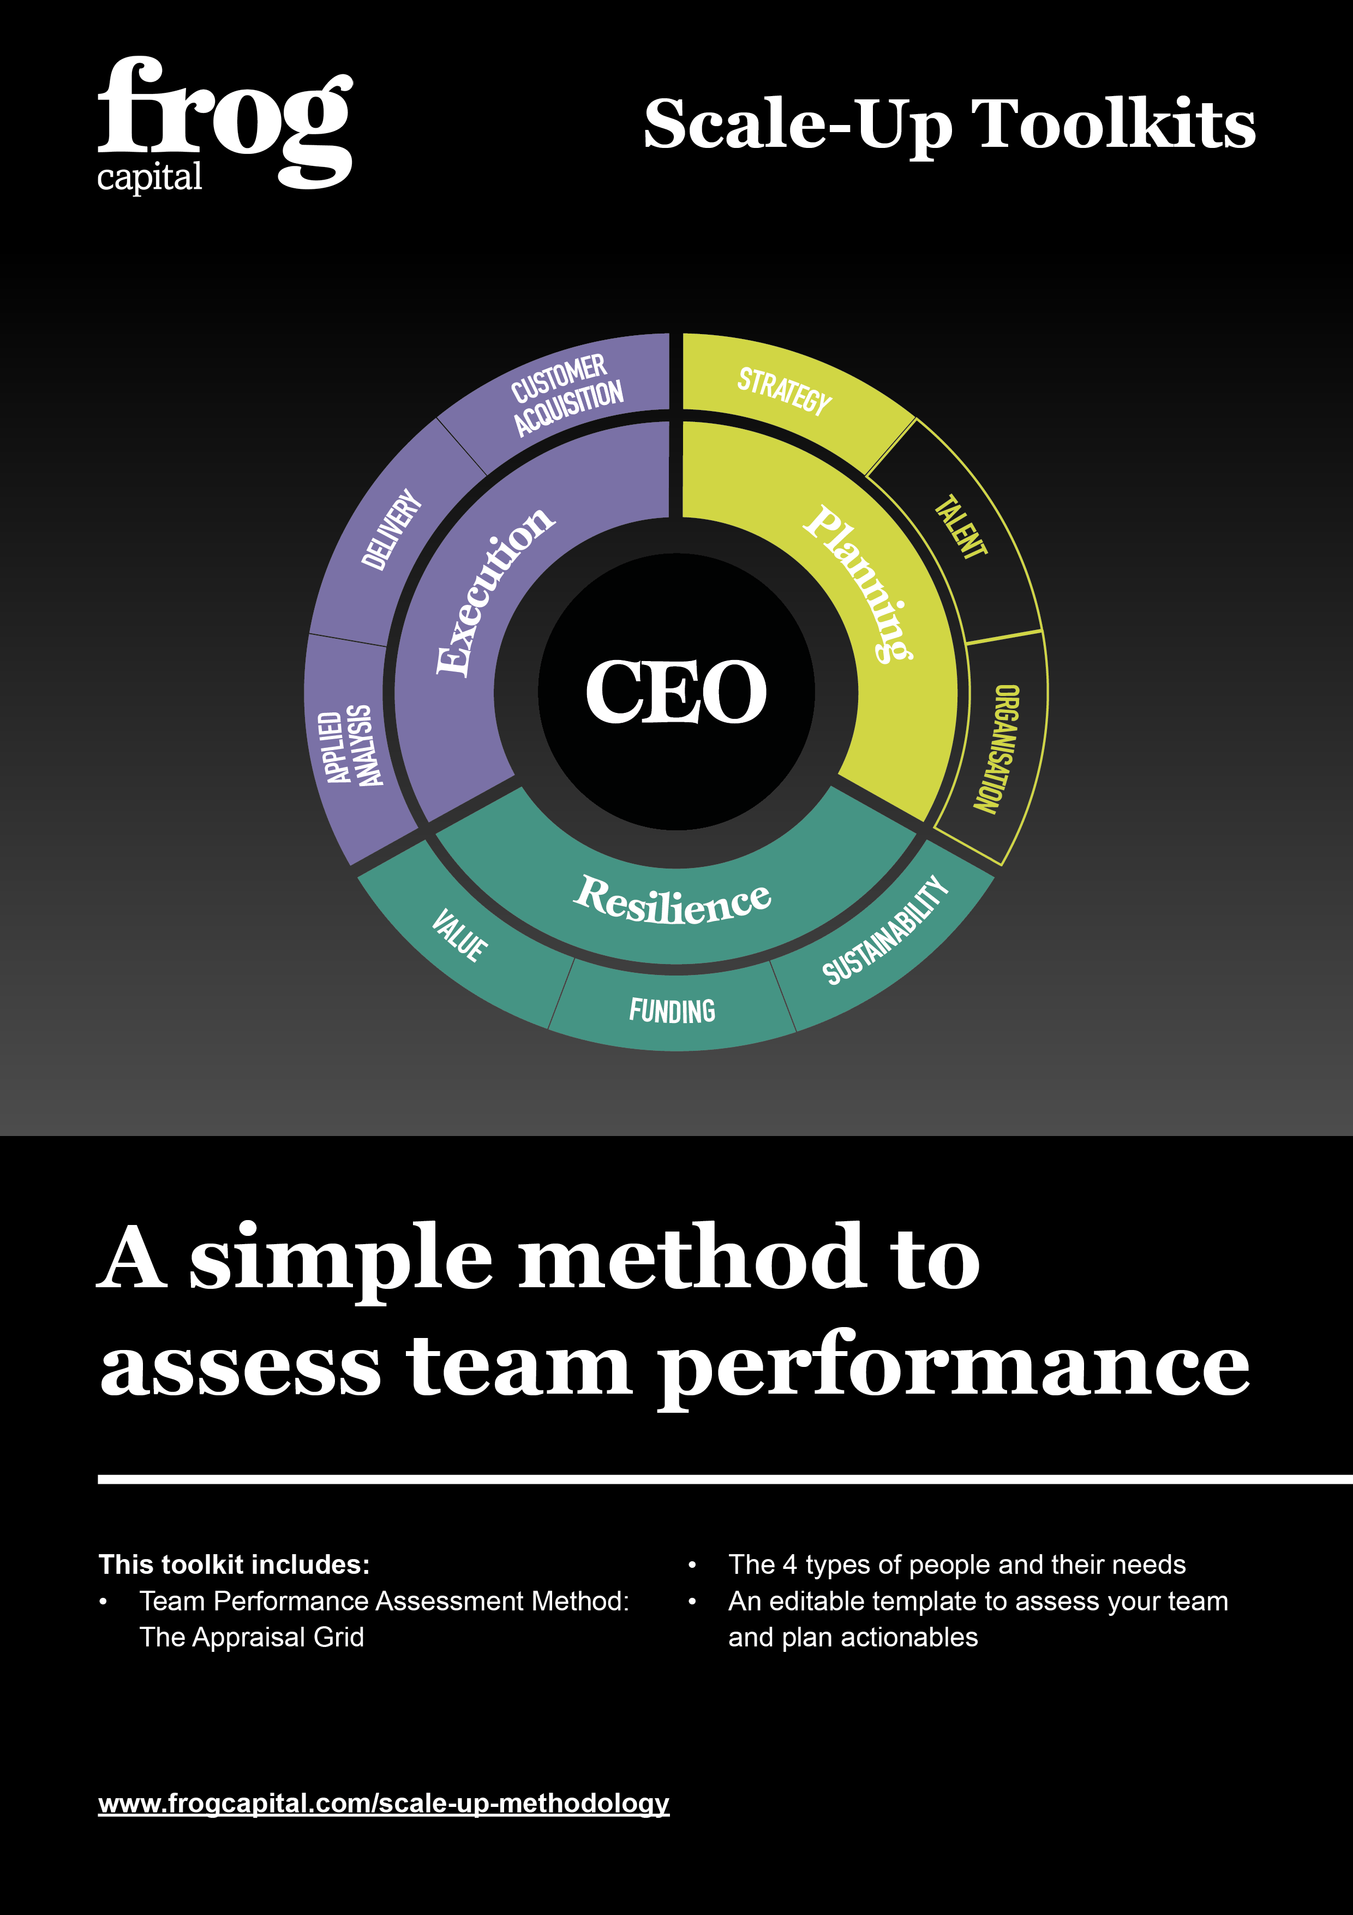
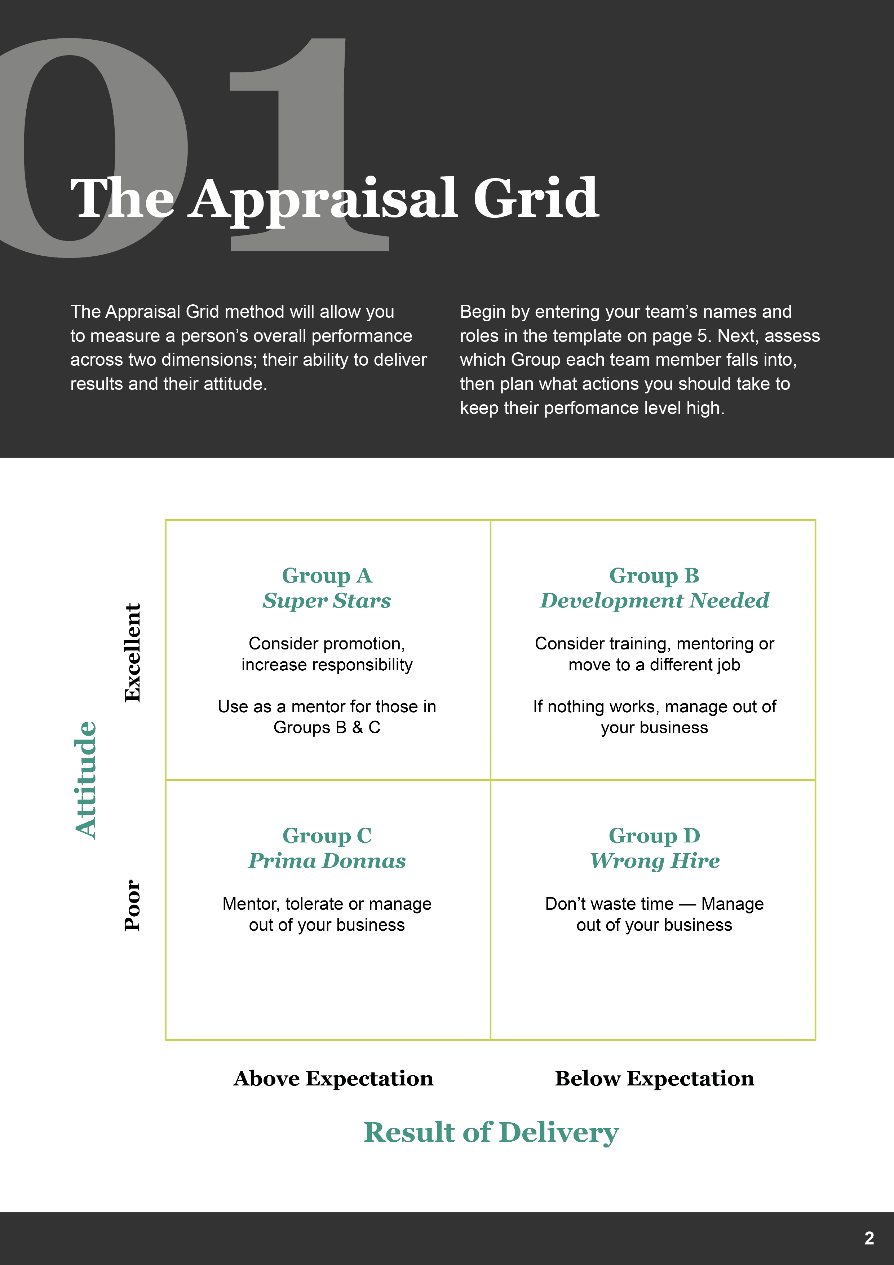
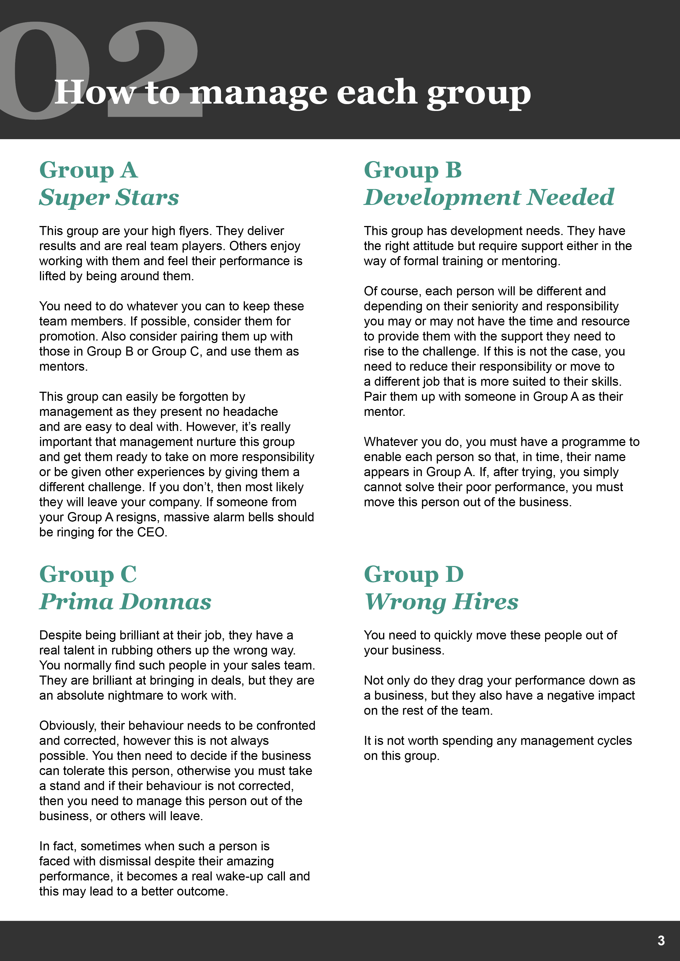
My Team

Name | Role | Group  (A, B, C or D) | Actions Required  & Timeframe
John Example | Sales Assistant | B | Pair with Alice Template on next project so Alice can mentor John – Start end of September

